Tesla Stocks

!pip install yfinance==0.1.67

!mamba install bs4==4.10.0 -y

!pip install nbformat==4.2.0

import yfinance as yf

import pandas as pd

import requests

from bs4 import BeautifulSoup

import plotly.graph_objects as go

from plotly.subplots import make_subplots

def make_graph(stock_data, revenue_data, stock):

fig = make_subplots(rows=2, cols=1, shared_xaxes=True, subplot_titles=("Historical Share Price", "Historical Revenue"), vertical_spacing = .3)

stock_data_specific = stock_data[stock_data.Date <= '2021--06-14']

revenue_data_specific = revenue_data[revenue_data.Date <= '2021-04-30']

fig.add_trace(go.Scatter(x=pd.to_datetime(stock_data_specific.Date, infer_datetime_format=True), y=stock_data_specific.Close.astype("float"), name="Share Price"), row=1, col=1)

fig.add_trace(go.Scatter(x=pd.to_datetime(revenue_data_specific.Date, infer_datetime_format=True), y=revenue_data_specific.Revenue.astype("float"), name="Revenue"), row=2, col=1)

fig.update_xaxes(title_text="Date", row=1, col=1)

fig.update_xaxes(title_text="Date", row=2, col=1)

fig.update_yaxes(title_text="Price ($US)", row=1, col=1)

fig.update_yaxes(title_text="Revenue ($US Millions)", row=2, col=1)

fig.update_layout(showlegend=False,

height=900,

title=stock,

xaxis_rangeslider_visible=True)

fig.show()

tesla = yf.Ticker("TSLA")

tesla_data = tesla.history(period="max")

tesla_data.reset_index(inplace=True)

tesla_data.head()

!pip install pandas==1.3.3

!pip install requests==2.26.0

!mamba install bs4==4.10.0 -y

!mamba install html5lib==1.1 -y

!pip install lxml==4.6.4

!pip install plotly==5.3.1

import pandas as pd

import requests

from bs4 import BeautifulSoup

url = "https://cf-courses-data.s3.us.cloud-object-storage.appdomain.cloud/IBMDeveloperSkillsNetwork-PY0220EN-SkillsNetwork/labs/project/revenue.htm"

html_data = requests.get(url).text

soup = BeautifulSoup(html_data,'html.parser')

tesla_revenue = pd.DataFrame(columns=["Date","Revenue"])

table = soup.find_all("tbody")[1]

for row in table.find_all("tr"):

col = row.find_all("td")

date = col[0].text

revenue = col[1].text

tesla_revenue = tesla_revenue.append({"Date": date, "Revenue": revenue}, ignore_index=True)

tesla_revenue["Revenue"] = tesla_revenue['Revenue'].str.replace(',|\$',"")

# to remove the comma and dollar signs

tesla_revenue.dropna(inplace=True)

tesla_revenue = tesla_revenue[tesla_revenue['Revenue'] != ""]

tesla_revenue.tail()

make_graph(tesla_data, tesla_revenue, 'Tesla')

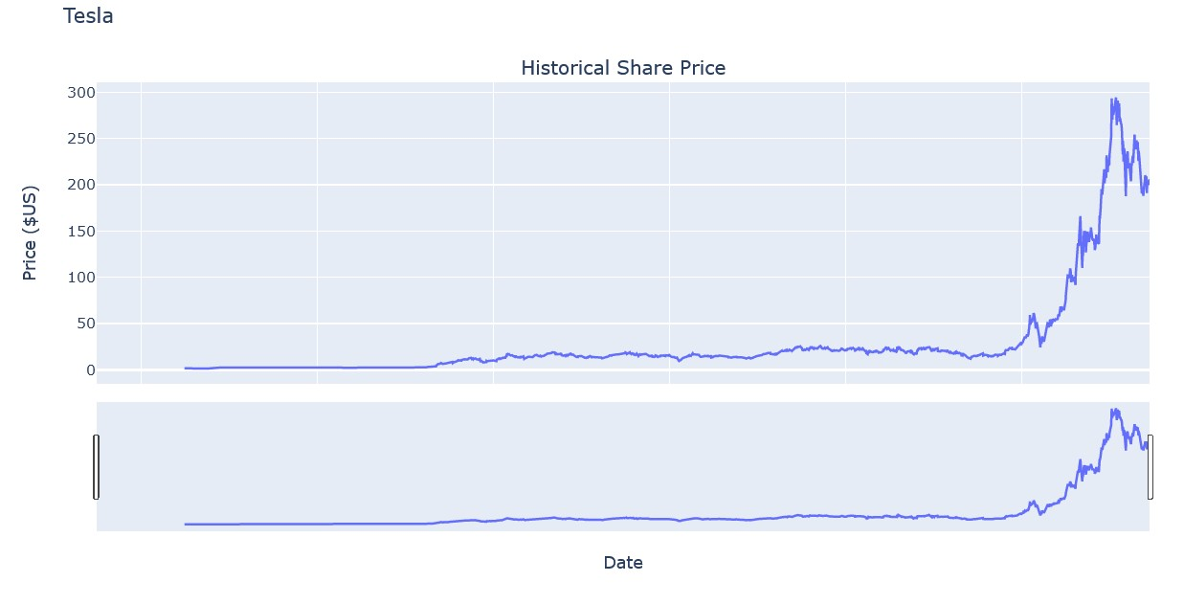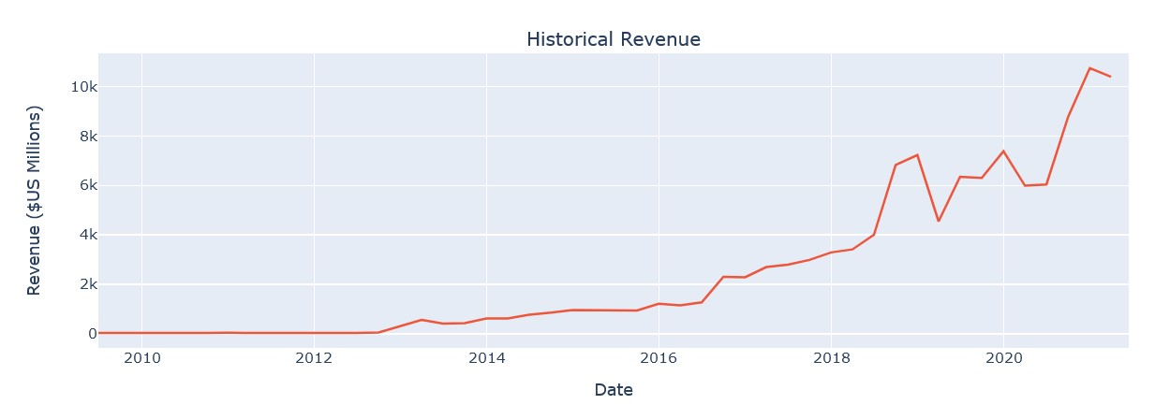

GME Stocks

!pip install yfinance==0.1.67

!mamba install bs4==4.10.0 -y

!pip install nbformat==4.2.0

import yfinance as yf

import pandas as pd

import requests

from bs4 import BeautifulSoup

import plotly.graph_objects as go

from plotly.subplots import make_subplots

def make_graph(stock_data, revenue_data, stock):

fig = make_subplots(rows=2, cols=1, shared_xaxes=True, subplot_titles=("Historical Share Price", "Historical Revenue"), vertical_spacing = .3)

stock_data_specific = stock_data[stock_data.Date <= '2021--06-14']

revenue_data_specific = revenue_data[revenue_data.Date <= '2021-04-30']

fig.add_trace(go.Scatter(x=pd.to_datetime(stock_data_specific.Date, infer_datetime_format=True), y=stock_data_specific.Close.astype("float"), name="Share Price"), row=1, col=1)

fig.add_trace(go.Scatter(x=pd.to_datetime(revenue_data_specific.Date, infer_datetime_format=True), y=revenue_data_specific.Revenue.astype("float"), name="Revenue"), row=2, col=1)

fig.update_xaxes(title_text="Date", row=1, col=1)

fig.update_xaxes(title_text="Date", row=2, col=1)

fig.update_yaxes(title_text="Price ($US)", row=1, col=1)

fig.update_yaxes(title_text="Revenue ($US Millions)", row=2, col=1)

fig.update_layout(showlegend=False,

height=900,

title=stock,

xaxis_rangeslider_visible=True)

fig.show()

gme = yf.Ticker("GME")

gme_data = gme.history(period="max")

gme_data.reset_index(inplace=True)

gme_data.head()

!pip install pandas==1.3.3

!pip install requests==2.26.0

!mamba install bs4==4.10.0 -y

!mamba install html5lib==1.1 -y

!pip install lxml==4.6.4

#!pip install plotly==5.3.1

import pandas as pd

import requests

from bs4 import BeautifulSoup

url = "https://cf-courses-data.s3.us.cloud-object-storage.appdomain.cloud/IBMDeveloperSkillsNetwork-PY0220EN-SkillsNetwork/labs/project/stock.html"

html_data = requests.get(url).text

soup = BeautifulSoup(html_data, 'html.parser')

gme_revenue= pd.DataFrame(columns=["Date", "Revenue"])

#table = soup.find_all("tbody")[1]

for row in soup.find_all("tbody")[1].find_all("tr"):

col = row.find_all("td")

date = col[0].text

revenue = col[1].text

gme_revenue = gme_revenue.append({"Date":date, "Revenue":revenue}, ignore_index=True)

gme_revenue["Revenue"] = gme_revenue['Revenue'].str.replace(',|\$',"")

# to remove the comma and dollar signs

gme_revenue.dropna(inplace=True) # to remove an null or empty strings

gme_revenue = gme_revenue[gme_revenue['Revenue'] != ""]

gme_revenue.tail()

make_graph(gme_data, gme_revenue, 'GameStop')

